PROMOTIONAL TASK 2

**Objective**: set up an infrastructure for a small business called kodecamp stores

| **Employees** | **Roles** | **Groups** | **Documents(directories)** | **Role Permissions** |
| --- | --- | --- | --- | --- |
| jeniffer | Sales Manager | Sales Team | Business Projections | * User: read and write * Group: read |
| Julius | legal | Legal team | Contract documents | * User: read, write * Group: read |
| Andrew | System Administrator | IT Team | Server Configuration Script | * User: read, write and execute * Group: read and execute |
| Gozie | IT intern | IT team | Server Configuration Script | * User: read, write and execute * Group: read and execute |
| chizi | Human Resource Manager | HR team | Employee Data | * User: read and write * Group: read |
| ogochukwu | Finance manager | Finance Team | Finance Budgets | * User: read and write * Group: read |
| Adeola | Business Strategies | Business Team | Business Models, Company Vision and Mission Statement | * User: read, write, * Group: read |
| Bach | CEO | Business team | Business Models, Company Vision and Mission Statement | * User: read and write * Group: read |

IMPLEMENTATION

1. To create the company kodecamp stores I have to create a group called kodecamp group and on with the command: *sudo groupadd Kodecamp_stores* 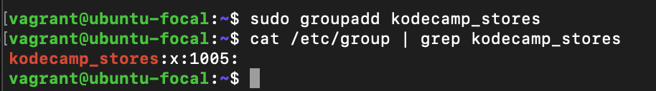
2. Then In implementing other groups creation I will use also use the groupadd command to avoid repetitive syntax a way to automate group creation is to use a for loop syntax  
   for group in it_team legal_team sales_team hr_team business_team finance_team; do sudo groupadd $group; done



1. Next is to create users all the users using the for loop I can create multiple users in one place
2. I went to implement adding each of the users to their respective groups and then to their supergroup which is kodecamp_stores with this command: *sudo gpasswd -a andrew it_team and* *sudo gpasswd -a andrew kodecamp_stores* as to create a relationship i also did so when I check for employees like andrew’s info i got this

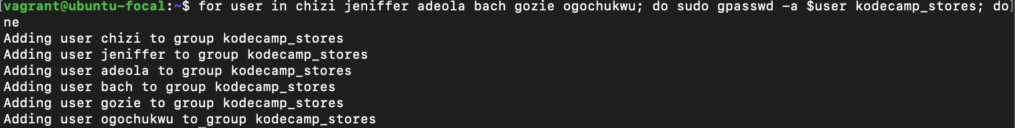

1. I went to create a directory called kodecamp_store with this command: *mkdir kodecamp_store*
2. *cd kodecamp_store*
3. *mkdir it_team legal_team sale_team hr_team business_team finance_team*
4. Now I get to create the dummy documents that is listed on the table above with the touch command eg *touch finance_team/finance_budget.txt*
5. Next is Granting the necessary ownership and permissions to the kodecamp_store directory to be only accessible to kodecamp_store and the users under them with this command: *sudo chgrp kodecamp_stores kodecamp_store/* and *sudo chmod 770 kodecamp_store/*

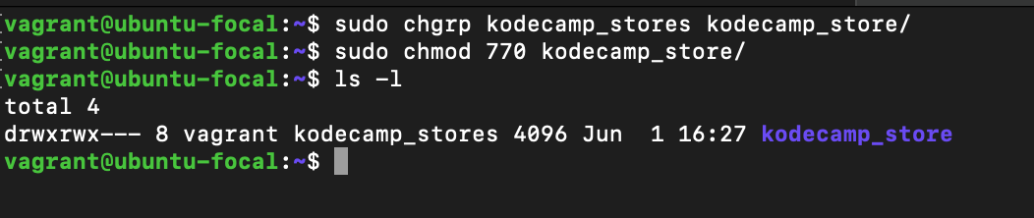

Note: Accessing the kodecamp store directory what’s noticeable after typing the *ls -l* commands is that ownership is still tied to vagrant and not kodecamp_stores unlike the picture above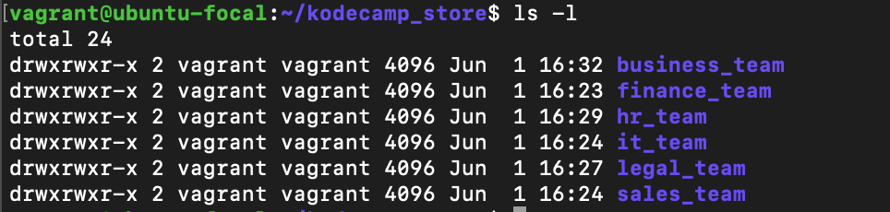

1. Assign permission and ownership to the folder in the kodecamp_store directory according to the table above to which group they belong to for example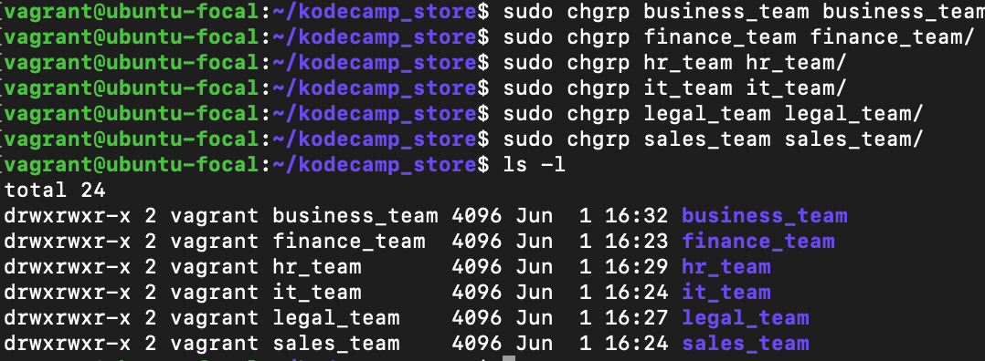

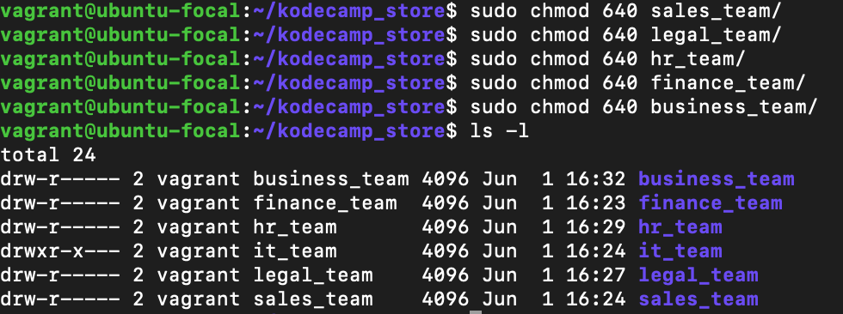

1. And observation after the whole permission has been done unless i use my admin access I can’t access the folders at

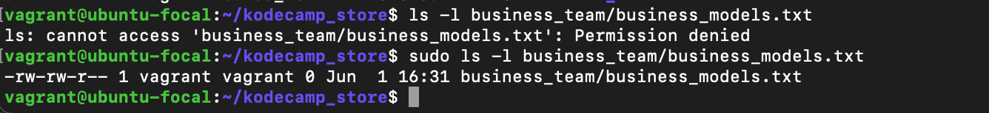

1. Here is the permissions in the document requested above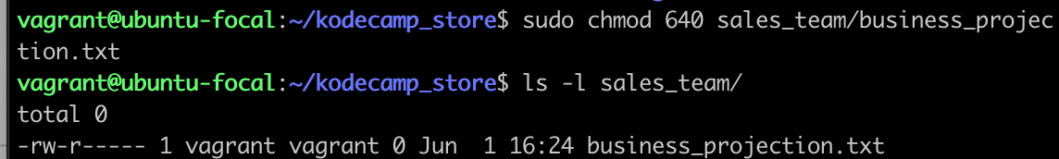

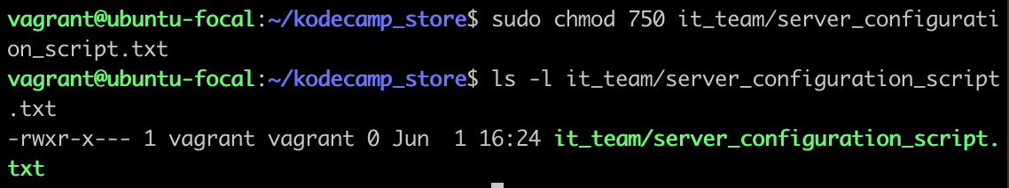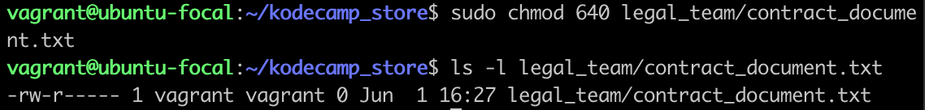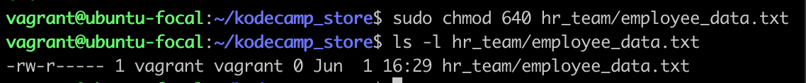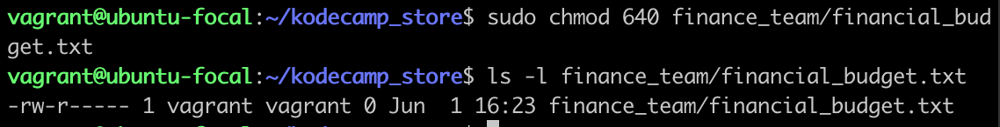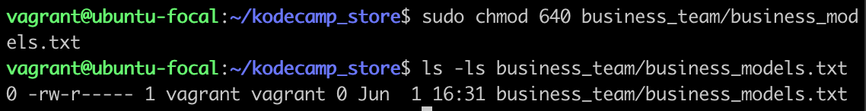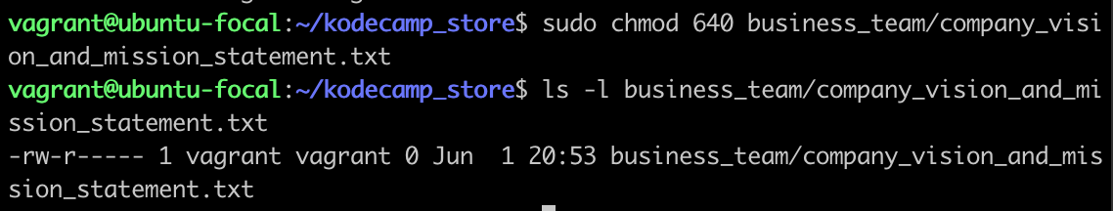

Note: I’ll be working towards understanding how permissions goes with directories